AI-Based Student Dropout Prediction & Counseling System

This document presents a comprehensive Salesforce implementation report for **the AI-Based Student Dropout Prediction & Counseling System.** The project is structured into 10 Phases, covering problem analysis, org setup, data modeling, automation, Apex development, UI, integrations, deployment, reporting & dashboards, and quality assurance testing.

# Phase 1: Problem Understanding & Industry Analysis

Phase 1: Problem Understanding & Industry Analysis focuses on implementing key Salesforce concepts for the AI Dropout Prediction System. Below are the detailed components with explanations and placeholders for screenshots.

## Requirement Gathering

Use Case: This section explains how 'Requirement Gathering' is applied in the context of the Student Dropout Prediction system. Provide detailed explanation here.

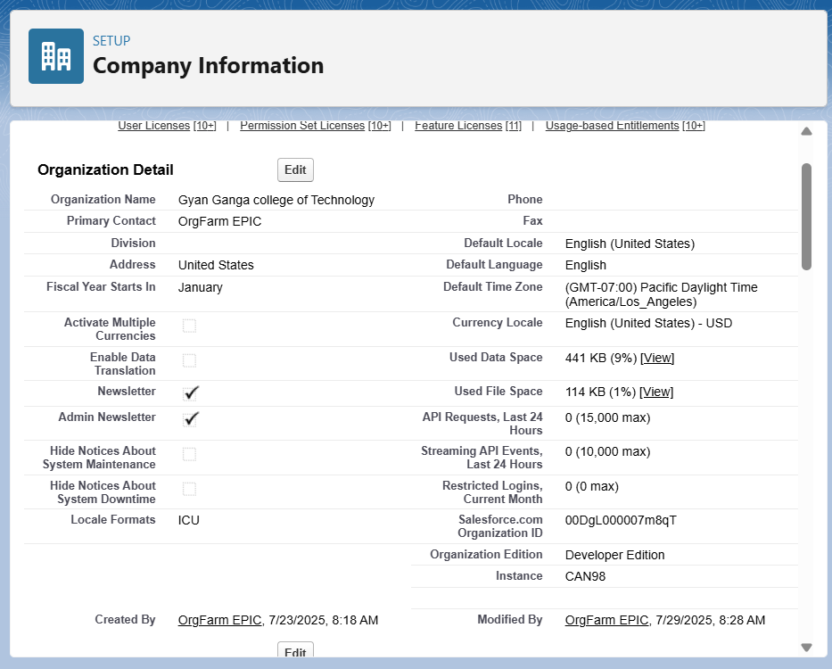

## Stakeholder Analysis

Use Case: This section explains how 'Stakeholder Analysis' is applied in the context of the Student Dropout Prediction system. Provide detailed explanation here.  
  
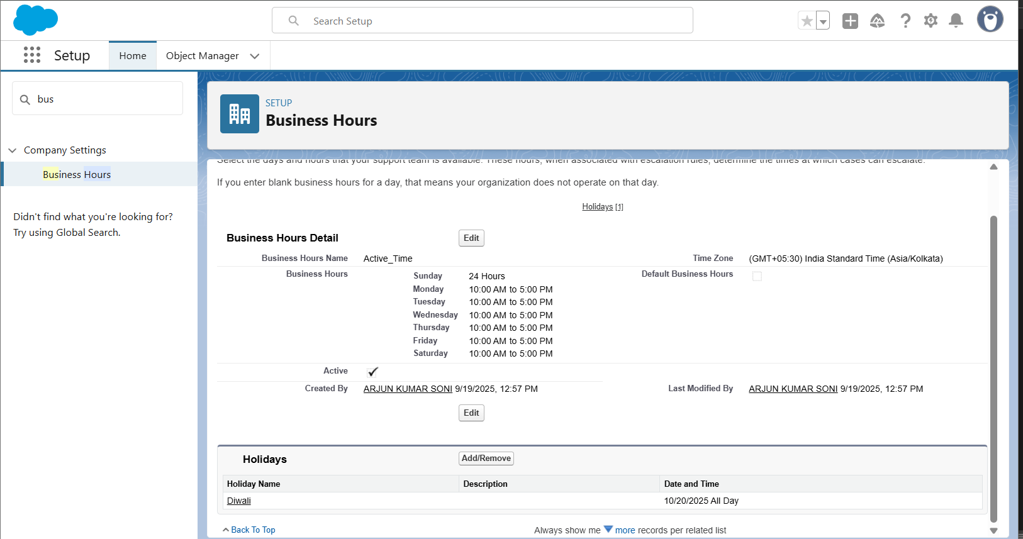

## Business Process Mapping

Use Case: This section explains how 'Business Process Mapping' is applied in the context of the Student Dropout Prediction system. Provide detailed explanation here.  
  
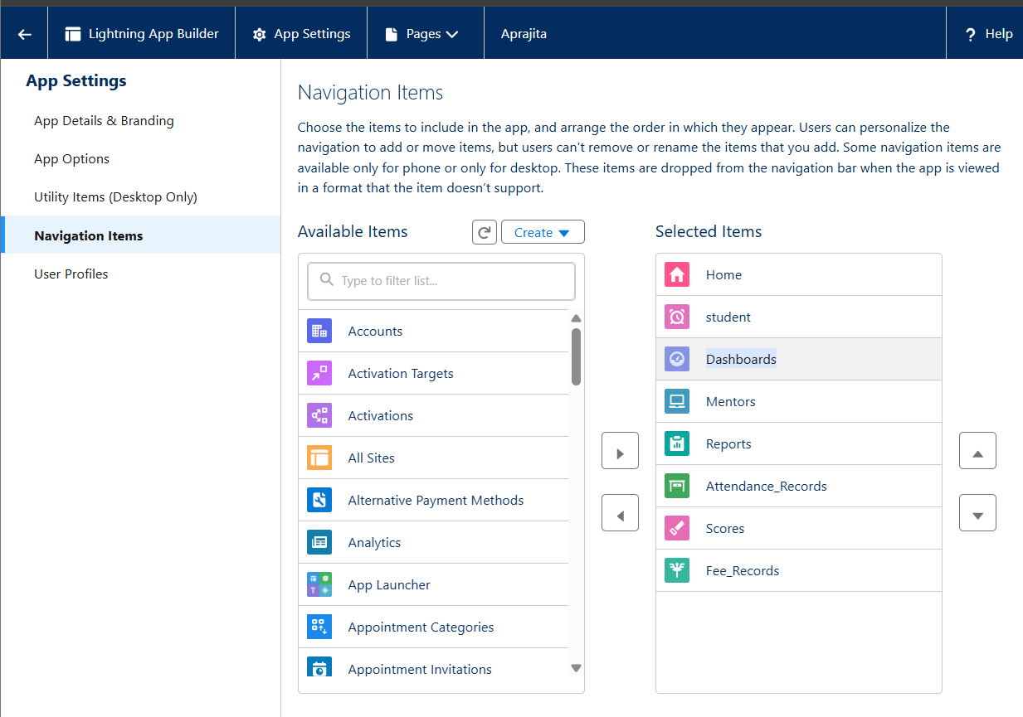

## Industry-specific Use Case Analysis

Use Case: This section explains how 'Industry-specific Use Case Analysis' is applied in the context of the Student Dropout Prediction system. Provide detailed explanation here.  
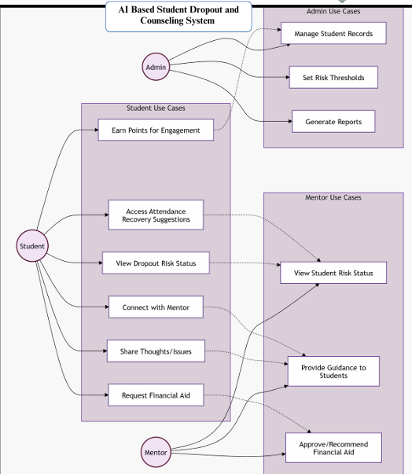

## AppExchange Exploration

Use Case: This section explains how 'AppExchange Exploration' is applied in the context of the Student Dropout Prediction system. Provide detailed explanation here.

**Phase 2: Org Setup & Configuration (Filled for**

**Project)**

**2: Org Setup & Configuration (Filled for**

**Project)**

# Salesforce Edition

Edition Used: Enterprise Edition (TCS Last Mile Program) Reason: Full access for Einstein, Experience Cloud, Apex, etc.

# 

# Company Profile Setup

Company Name**: AI Dropout Prediction & Counselling System** – Demo Institute

Time Zone: IST (GMT+5:30)

Currency: INR

Notes: Aligns with academic & financial reporting.



# Business Hours & Holidays

Working Hours: Mon–Fri, 10 AM – 5 PM

Holidays: Independence Day (15 Aug), Republic Day (26 Jan), Diwali, University Annual Day Importance: Ensures alerts/notifications not sent outside working hours



# Fiscal Year Settings

Fiscal Year Type: Custom Fiscal Year

Academic Year: July – June

Notes: Matches university academic cycle.

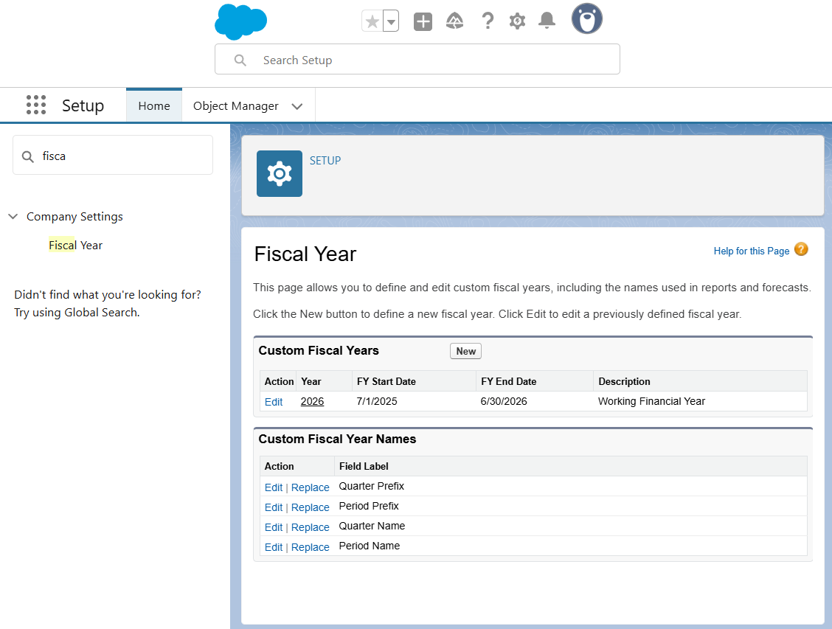

# User Setup & Licenses

Roles and Licenses table provided below.

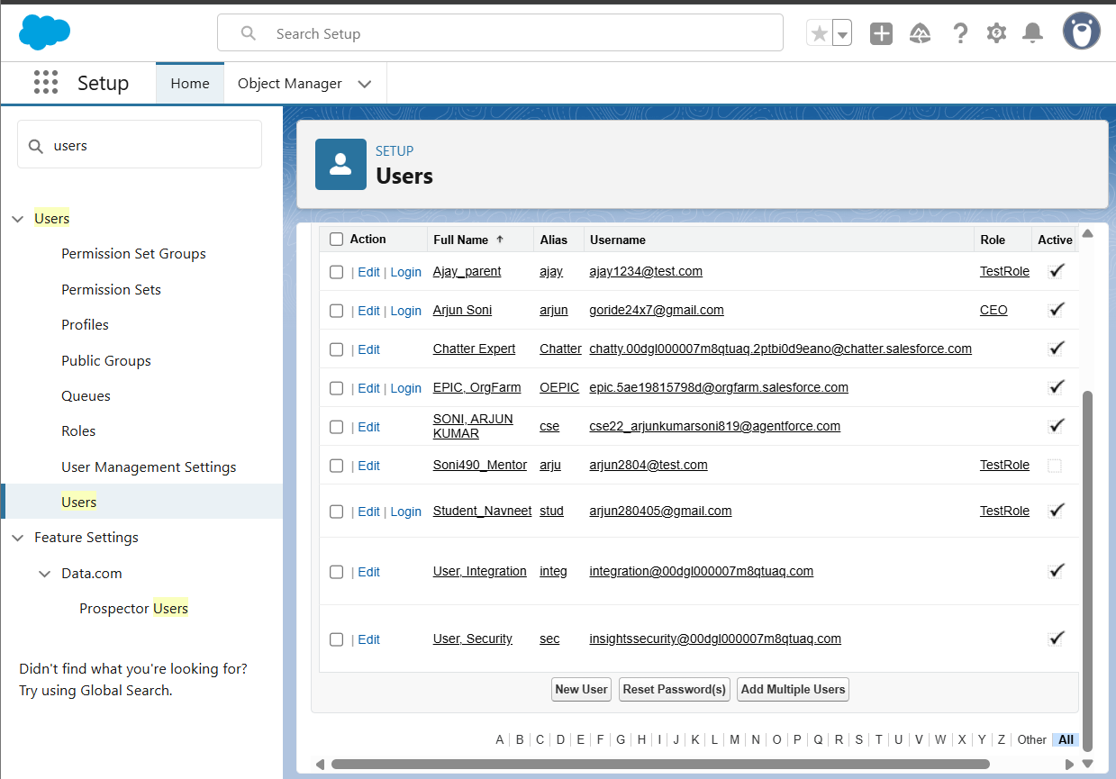

# Profiles

Student Profile → Read-only on own data

Parent Profile → Read-only on child’s data

Mentor Profile → Read/Write for assigned students

Admin Profile → Full Access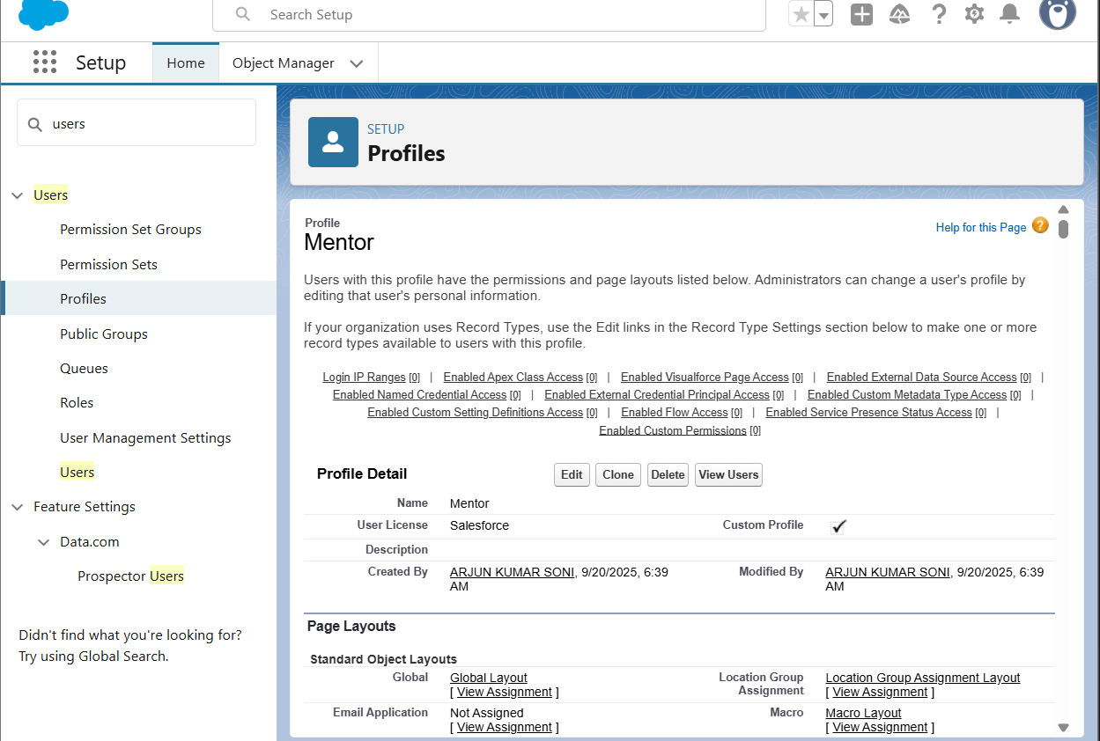

# 7.Roles:

Role Hierarchy:

* Admin
* Mentor
* Student

Parent (via lookup) 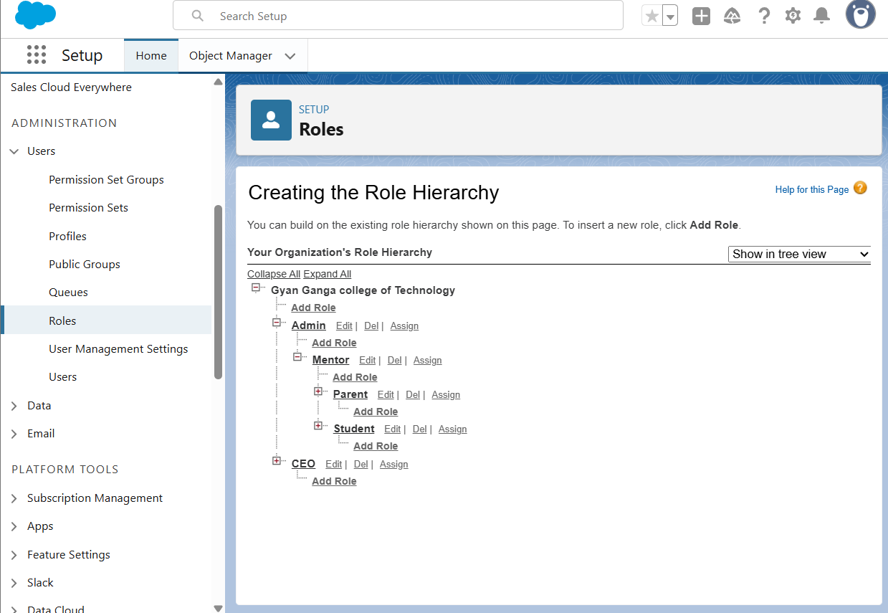

# 8.Permission Sets

Scholarship Access → Assigned to Admins

LMS Access → Assigned to Students

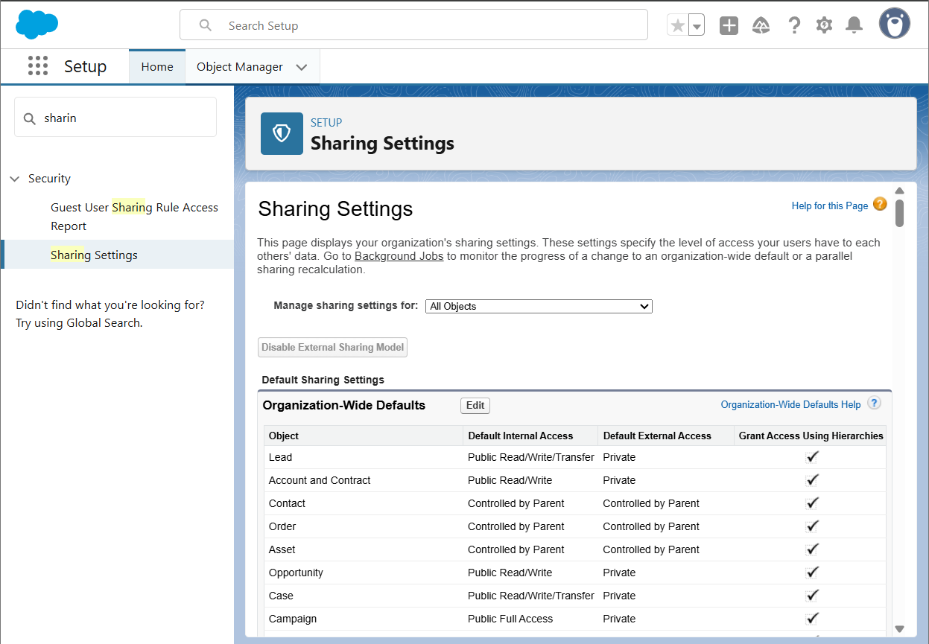

# OWD (Organization-Wide Defaults)

# 

# 10.Sharing Rules

Rule 1: Share Student data with Parent via Lookup.

Rule 2: Share 'At-Risk Student' records automatically with Mentors.

## 13.User Setup & Licenses

|  |  |  |
| --- | --- | --- |
| Role | User Type | License Assigned |
| Student | Platform/Experience | Experience Cloud User |
| Parent | Community/Experience | Read-only Community User |
| Mentor | Standard User | Salesforce License |
| Admin | System Administrator | Full Access |

## 14.Profiles Permission Matrix

|  |  |  |  |  |
| --- | --- | --- | --- | --- |
| Profile | Read | Create | Update | Delete |
| Student | ✔ (own records) | ✖ | ✖ | ✖ |
| Parent | ✔ (child records) | ✖ | ✖ | ✖ |
| Mentor | ✔ | ✔ | ✔ | ✖ |
| Admin | ✔ | ✔ | ✔ | ✔ |

## 15.OWD (Organization-Wide Defaults)

|  |  |  |
| --- | --- | --- |
| Object | Default Access | Notes |
| Student | Private | Each student sees only their own data |
| Attendance | Controlled by Parent | Linked to Student |
| Fees | Private | Shared only with Parents & Mentors |
| Assessments | Private | Mentor has access to assigned students |

# Phase 3: Data Modeling & Relationships

Phase 3: Data Modeling & Relationships focuses on implementing key Salesforce concepts for the AI Dropout Prediction System. Below are the detailed components with explanations and placeholders for screenshots.

## Standard & Custom Objects

Use Case: This section explains how 'Standard & Custom Objects' is applied in the context of the Student Dropout Prediction system. Provide detailed explanation here.  
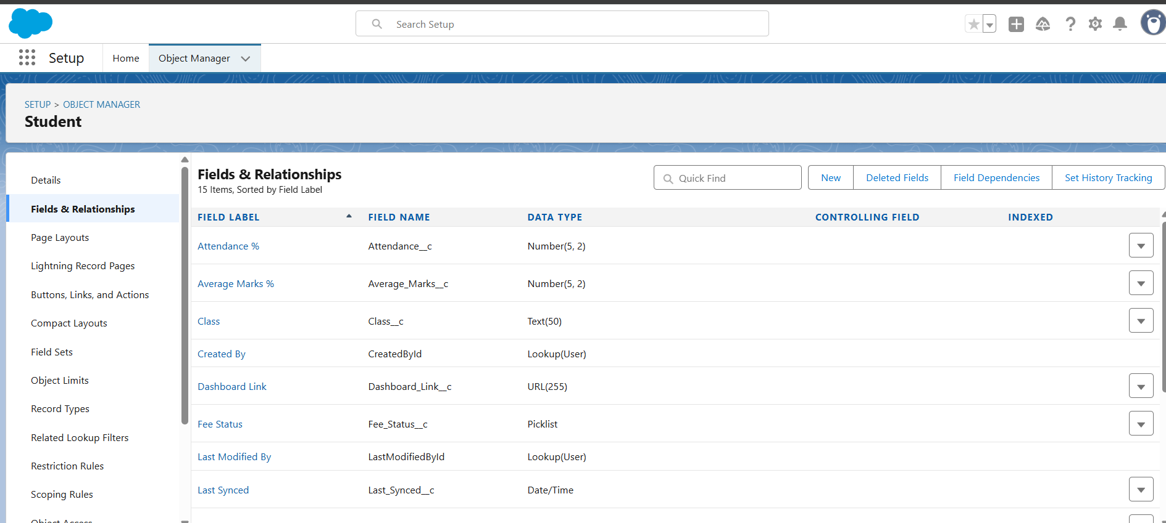

## Fields

Use Case: This section explains how 'Fields' is applied in the context of the Student Dropout Prediction system. Provide detailed explanation here.  


## Record Types

Use Case: This section explains how 'Record Types' is applied in the context of the Student Dropout Prediction system. Provide detailed explanation here.

## Page Layouts

Use Case: This section explains how 'Page Layouts' is applied in the context of the Student Dropout Prediction system. Provide detailed explanation here.

## Compact Layouts

Use Case: This section explains how 'Compact Layouts' is applied in the context of the Student Dropout Prediction system. Provide detailed explanation here.  
  
Screenshot Placeholder: Insert relevant Salesforce screenshot here.

## Schema Builder

Use Case: This section explains how 'Schema Builder' is applied in the context of the Student Dropout Prediction system. Provide detailed explanation here.  
  
Screenshot Placeholder: Insert relevant Salesforce screenshot here.

## Lookup vs Master-Detail vs Hierarchical Relationships

Use Case: This section explains how 'Lookup vs Master-Detail vs Hierarchical Relationships' is applied in the context of the Student Dropout Prediction system. Provide detailed explanation here

## Junction Objects

Use Case: This section explains how 'Junction Objects' is applied in the context of the Student Dropout Prediction system. Provide detailed explanation here.  
  
Screenshot Placeholder: Insert relevant Salesforce screenshot here.

## External Objects

Use Case: This section explains how 'External Objects' is applied in the context of the Student Dropout Prediction system. Provide detailed explanation here.  
  
Screenshot Placeholder: Insert relevant Salesforce screenshot here.

# Phase 4: Process Automation (Admin)

Phase 4: Process Automation (Admin) focuses on implementing key Salesforce concepts for the AI Dropout Prediction System. Below are the detailed components with explanations and placeholders for screenshots.

## Validation Rules

Use Case: This section explains how 'Validation Rules' is applied in the context of the Student Dropout Prediction system. Provide detailed explanation here.  
  
.

## Workflow Rules

Use Case: This section explains how 'Workflow Rules' is applied in the context of the Student Dropout Prediction system. Provide detailed explanation here.  


## Process Builder

Use Case: This section explains how 'Process Builder' is applied in the context of the Student Dropout Prediction system. Provide detailed explanation here.

## Approval Process

Use Case: This section explains how 'Approval Process' is applied in the context of the Student Dropout Prediction system. Provide detailed explanation here.  
  
Screenshot Placeholder: Insert relevant Salesforce screenshot here.

## Flow Builder

Use Case: This section explains how 'Flow Builder' is applied in the context of the Student Dropout Prediction system. Provide detailed explanation here.  
.

## Email Alerts

Use Case: This section explains how 'Email Alerts' is applied in the context of the Student Dropout Prediction system. Provide detailed explanation here.

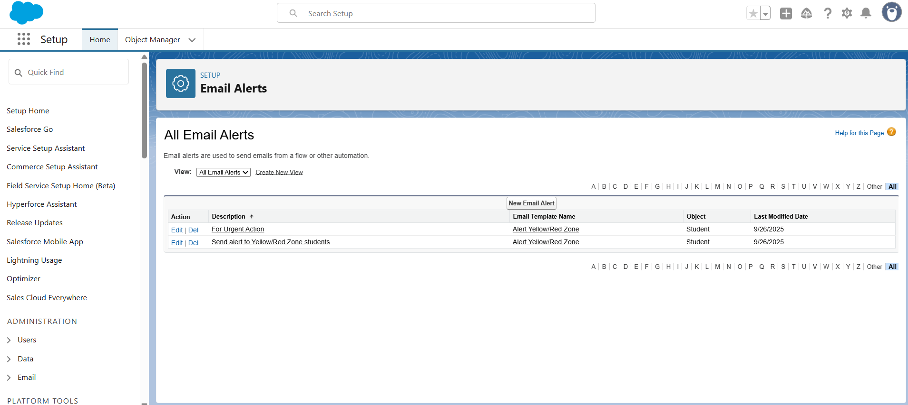

## Field Updates

Use Case: This section explains how 'Field Updates' is applied in the context of the Student Dropout Prediction system. Provide detailed explanation here.  
  
Tasks

Use Case: This section explains how 'Tasks' is applied in the context of the Student Dropout Prediction system. Provide detailed explanation here.  
  
Screenshot Placeholder: Insert relevant Salesforce screenshot here.

## Custom Notifications

Use Case: This section explains how 'Custom Notifications' is applied in the context of the Student Dropout Prediction system. Provide detailed explanation here.

# Phase 5: Apex Programming (Developer)

Phase 5: Apex Programming (Developer) focuses on implementing key Salesforce concepts for the AI Dropout Prediction System. Below are the detailed components with explanations and placeholders for screenshots.

## Classes & Objects

Use Case: This section explains how 'Classes & Objects' is applied in the context of the Student Dropout Prediction system. Provide detailed explanation here.  
  
Screenshot Placeholder: Insert relevant Salesforce screenshot here.

## Apex Triggers

Use Case: This section explains how 'Apex Triggers' is applied in the context of the Student Dropout Prediction system. Provide detailed explanation here.  
  
Screenshot Placeholder: Insert relevant Salesforce screenshot here.

## Trigger Design Pattern

Use Case: This section explains how 'Trigger Design Pattern' is applied in the context of the Student Dropout Prediction system. Provide detailed explanation here.  
  
Screenshot Placeholder: Insert relevant Salesforce screenshot here.

## SOQL & SOSL

Use Case: This section explains how 'SOQL & SOSL' is applied in the context of the Student Dropout Prediction system. Provide detailed explanation here.  
  
Screenshot Placeholder: Insert relevant Salesforce screenshot here.

## Collections

Use Case: This section explains how 'Collections' is applied in the context of the Student Dropout Prediction system. Provide detailed explanation here.  
  
Screenshot Placeholder: Insert relevant Salesforce screenshot here.

## Control Statements

Use Case: This section explains how 'Control Statements' is applied in the context of the Student Dropout Prediction system. Provide detailed explanation here.  
  
Screenshot Placeholder: Insert relevant Salesforce screenshot here.

## Batch Apex

Use Case: This section explains how 'Batch Apex' is applied in the context of the Student Dropout Prediction system. Provide detailed explanation here.  
  
Screenshot Placeholder: Insert relevant Salesforce screenshot here.

## Queueable Apex

Use Case: This section explains how 'Queueable Apex' is applied in the context of the Student Dropout Prediction system. Provide detailed explanation here.  
  
Screenshot Placeholder: Insert relevant Salesforce screenshot here.

## Scheduled Apex

Use Case: This section explains how 'Scheduled Apex' is applied in the context of the Student Dropout Prediction system. Provide detailed explanation here.  
  
Screenshot Placeholder: Insert relevant Salesforce screenshot here.

## Future Methods

Use Case: This section explains how 'Future Methods' is applied in the context of the Student Dropout Prediction system. Provide detailed explanation here.  
  
Screenshot Placeholder: Insert relevant Salesforce screenshot here.

## Exception Handling

Use Case: This section explains how 'Exception Handling' is applied in the context of the Student Dropout Prediction system. Provide detailed explanation here.  
  
Screenshot Placeholder: Insert relevant Salesforce screenshot here.

## Test Classes

Use Case: This section explains how 'Test Classes' is applied in the context of the Student Dropout Prediction system. Provide detailed explanation here.  
  
Screenshot Placeholder: Insert relevant Salesforce screenshot here.

## Asynchronous Processing

Use Case: This section explains how 'Asynchronous Processing' is applied in the context of the Student Dropout Prediction system. Provide detailed explanation here.  
  
Screenshot Placeholder: Insert relevant Salesforce screenshot here.

# Phase 6: User Interface Development

Phase 6: User Interface Development focuses on implementing key Salesforce concepts for the AI Dropout Prediction System. Below are the detailed components with explanations and placeholders for screenshots.

## Lightning App Builder

Use Case: This section explains how 'Lightning App Builder' is applied in the context of the Student Dropout Prediction system. Provide detailed explanation here.  
  
Screenshot Placeholder: Insert relevant Salesforce screenshot here.

## Record Pages

Use Case: This section explains how 'Record Pages' is applied in the context of the Student Dropout Prediction system. Provide detailed explanation here.  
  
Screenshot Placeholder: Insert relevant Salesforce screenshot here.

## Tabs

Use Case: This section explains how 'Tabs' is applied in the context of the Student Dropout Prediction system. Provide detailed explanation here.  
  
Screenshot Placeholder: Insert relevant Salesforce screenshot here.

## Home Page Layouts

Use Case: This section explains how 'Home Page Layouts' is applied in the context of the Student Dropout Prediction system. Provide detailed explanation here.  
  
Screenshot Placeholder: Insert relevant Salesforce screenshot here.

## Utility Bar

Use Case: This section explains how 'Utility Bar' is applied in the context of the Student Dropout Prediction system. Provide detailed explanation here.  
  
Screenshot Placeholder: Insert relevant Salesforce screenshot here.

## LWC (Lightning Web Components)

Use Case: This section explains how 'LWC (Lightning Web Components)' is applied in the context of the Student Dropout Prediction system. Provide detailed explanation here.  
  
Screenshot Placeholder: Insert relevant Salesforce screenshot here.

## Apex with LWC

Use Case: This section explains how 'Apex with LWC' is applied in the context of the Student Dropout Prediction system. Provide detailed explanation here.  
  
Screenshot Placeholder: Insert relevant Salesforce screenshot here.

## Events in LWC

Use Case: This section explains how 'Events in LWC' is applied in the context of the Student Dropout Prediction system. Provide detailed explanation here.  
  
Screenshot Placeholder: Insert relevant Salesforce screenshot here.

## Wire Adapters

Use Case: This section explains how 'Wire Adapters' is applied in the context of the Student Dropout Prediction system. Provide detailed explanation here.  
  
Screenshot Placeholder: Insert relevant Salesforce screenshot here.

## Imperative Apex Calls

Use Case: This section explains how 'Imperative Apex Calls' is applied in the context of the Student Dropout Prediction system. Provide detailed explanation here.  
  
Screenshot Placeholder: Insert relevant Salesforce screenshot here.

## Navigation Service

Use Case: This section explains how 'Navigation Service' is applied in the context of the Student Dropout Prediction system. Provide detailed explanation here.  
  
Screenshot Placeholder: Insert relevant Salesforce screenshot here.

# Phase 7: Integration & External Access

Phase 7: Integration & External Access focuses on implementing key Salesforce concepts for the AI Dropout Prediction System. Below are the detailed components with explanations and placeholders for screenshots.

## Named Credentials

Use Case: This section explains how 'Named Credentials' is applied in the context of the Student Dropout Prediction system. Provide detailed explanation here.  
  
Screenshot Placeholder: Insert relevant Salesforce screenshot here.

## External Services

Use Case: This section explains how 'External Services' is applied in the context of the Student Dropout Prediction system. Provide detailed explanation here.  
  
Screenshot Placeholder: Insert relevant Salesforce screenshot here.

## Web Services (REST/SOAP)

Use Case: This section explains how 'Web Services (REST/SOAP)' is applied in the context of the Student Dropout Prediction system. Provide detailed explanation here.  
  
Screenshot Placeholder: Insert relevant Salesforce screenshot here.

## Callouts

Use Case: This section explains how 'Callouts' is applied in the context of the Student Dropout Prediction system. Provide detailed explanation here.  
  
Screenshot Placeholder: Insert relevant Salesforce screenshot here.

## Platform Events

Use Case: This section explains how 'Platform Events' is applied in the context of the Student Dropout Prediction system. Provide detailed explanation here.  
  
Screenshot Placeholder: Insert relevant Salesforce screenshot here.

## Change Data Capture

Use Case: This section explains how 'Change Data Capture' is applied in the context of the Student Dropout Prediction system. Provide detailed explanation here.  
  
Screenshot Placeholder: Insert relevant Salesforce screenshot here.

## Salesforce Connect

Use Case: This section explains how 'Salesforce Connect' is applied in the context of the Student Dropout Prediction system. Provide detailed explanation here.  
  
Screenshot Placeholder: Insert relevant Salesforce screenshot here.

## API Limits

Use Case: This section explains how 'API Limits' is applied in the context of the Student Dropout Prediction system. Provide detailed explanation here.  
  
Screenshot Placeholder: Insert relevant Salesforce screenshot here.

## OAuth & Authentication

Use Case: This section explains how 'OAuth & Authentication' is applied in the context of the Student Dropout Prediction system. Provide detailed explanation here.  
  
Screenshot Placeholder: Insert relevant Salesforce screenshot here.

## Remote Site Settings

Use Case: This section explains how 'Remote Site Settings' is applied in the context of the Student Dropout Prediction system. Provide detailed explanation here.  
  
Screenshot Placeholder: Insert relevant Salesforce screenshot here.

# Phase 8: Data Management & Deployment

Phase 8: Data Management & Deployment focuses on implementing key Salesforce concepts for the AI Dropout Prediction System. Below are the detailed components with explanations and placeholders for screenshots.

## Data Import Wizard

Use Case: This section explains how 'Data Import Wizard' is applied in the context of the Student Dropout Prediction system. Provide detailed explanation here.  
  
Screenshot Placeholder: Insert relevant Salesforce screenshot here.

## Data Loader

Use Case: This section explains how 'Data Loader' is applied in the context of the Student Dropout Prediction system. Provide detailed explanation here.  
  
Screenshot Placeholder: Insert relevant Salesforce screenshot here.

## Duplicate Rules

Use Case: This section explains how 'Duplicate Rules' is applied in the context of the Student Dropout Prediction system. Provide detailed explanation here.  
  
Screenshot Placeholder: Insert relevant Salesforce screenshot here.

## Data Export & Backup

Use Case: This section explains how 'Data Export & Backup' is applied in the context of the Student Dropout Prediction system. Provide detailed explanation here.  
  
Screenshot Placeholder: Insert relevant Salesforce screenshot here.

## Change Sets

Use Case: This section explains how 'Change Sets' is applied in the context of the Student Dropout Prediction system. Provide detailed explanation here.  
  
Screenshot Placeholder: Insert relevant Salesforce screenshot here.

## Unmanaged vs Managed Packages

Use Case: This section explains how 'Unmanaged vs Managed Packages' is applied in the context of the Student Dropout Prediction system. Provide detailed explanation here.  
  
Screenshot Placeholder: Insert relevant Salesforce screenshot here.

## ANT Migration Tool

Use Case: This section explains how 'ANT Migration Tool' is applied in the context of the Student Dropout Prediction system. Provide detailed explanation here.  
  
Screenshot Placeholder: Insert relevant Salesforce screenshot here.

## VS Code & SFDX

Use Case: This section explains how 'VS Code & SFDX' is applied in the context of the Student Dropout Prediction system. Provide detailed explanation here.  
  
Screenshot Placeholder: Insert relevant Salesforce screenshot here.

# Phase 9: Reporting, Dashboards & Security Review

Phase 9: Reporting, Dashboards & Security Review focuses on implementing key Salesforce concepts for the AI Dropout Prediction System. Below are the detailed components with explanations and placeholders for screenshots.

## Reports

Use Case: This section explains how 'Reports' is applied in the context of the Student Dropout Prediction system. Provide detailed explanation here.  
  
Screenshot Placeholder: Insert relevant Salesforce screenshot here.

## Report Types

Use Case: This section explains how 'Report Types' is applied in the context of the Student Dropout Prediction system. Provide detailed explanation here.  
  
Screenshot Placeholder: Insert relevant Salesforce screenshot here.

## Dashboards

Use Case: This section explains how 'Dashboards' is applied in the context of the Student Dropout Prediction system. Provide detailed explanation here.  
  


## Dynamic Dashboards

Use Case: This section explains how 'Dynamic Dashboards' is applied in the context of the Student Dropout Prediction system. Provide detailed explanation here.  
  
Screenshot Placeholder: Insert relevant Salesforce screenshot here.

## Profiles

Use Case: This section explains how 'Profiles' is applied in the context of the Student Dropout Prediction system. Provide detailed explanation here.  
  
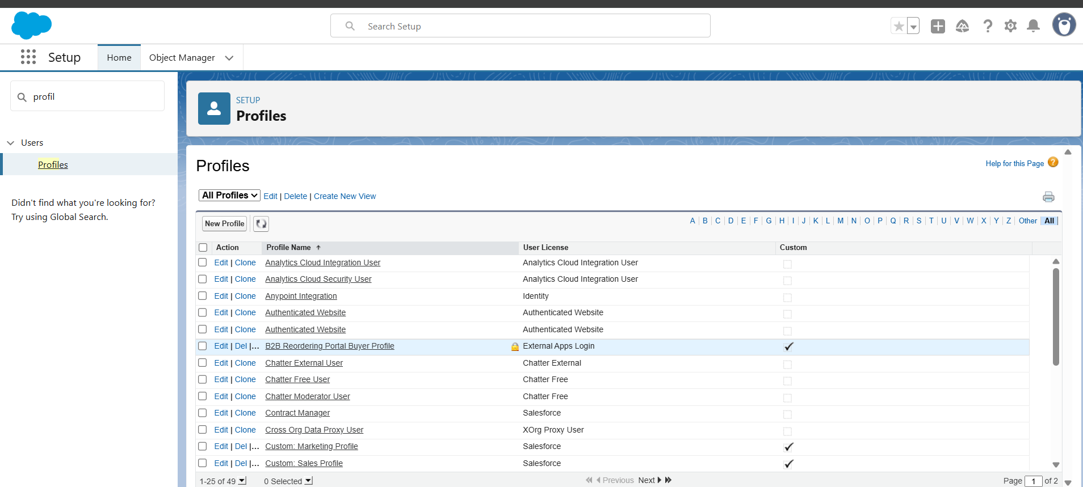

## Roles

Use Case: This section explains how 'Roles' is applied in the context of the Student Dropout Prediction system. Provide detailed explanation here.  
  
Screenshot Placeholder: Insert relevant Salesforce screenshot here.

## Users

Use Case: This section explains how 'Users' is applied in the context of the Student Dropout Prediction system. Provide detailed explanation here.  
  
Screenshot Placeholder: Insert relevant Salesforce screenshot here.

## Permission Sets

Use Case: This section explains how 'Permission Sets' is applied in the context of the Student Dropout Prediction system. Provide detailed explanation here.  
  
Screenshot Placeholder: Insert relevant Salesforce screenshot here.

## OWD

Use Case: This section explains how 'OWD' is applied in the context of the Student Dropout Prediction system. Provide detailed explanation here.  
  
Screenshot Placeholder: Insert relevant Salesforce screenshot here.

## Sharing Rules

Use Case: This section explains how 'Sharing Rules' is applied in the context of the Student Dropout Prediction system. Provide detailed explanation here.

## Sharing Settings

Use Case: This section explains how 'Sharing Settings' is applied in the context of the Student Dropout Prediction system. Provide detailed explanation here.  
  
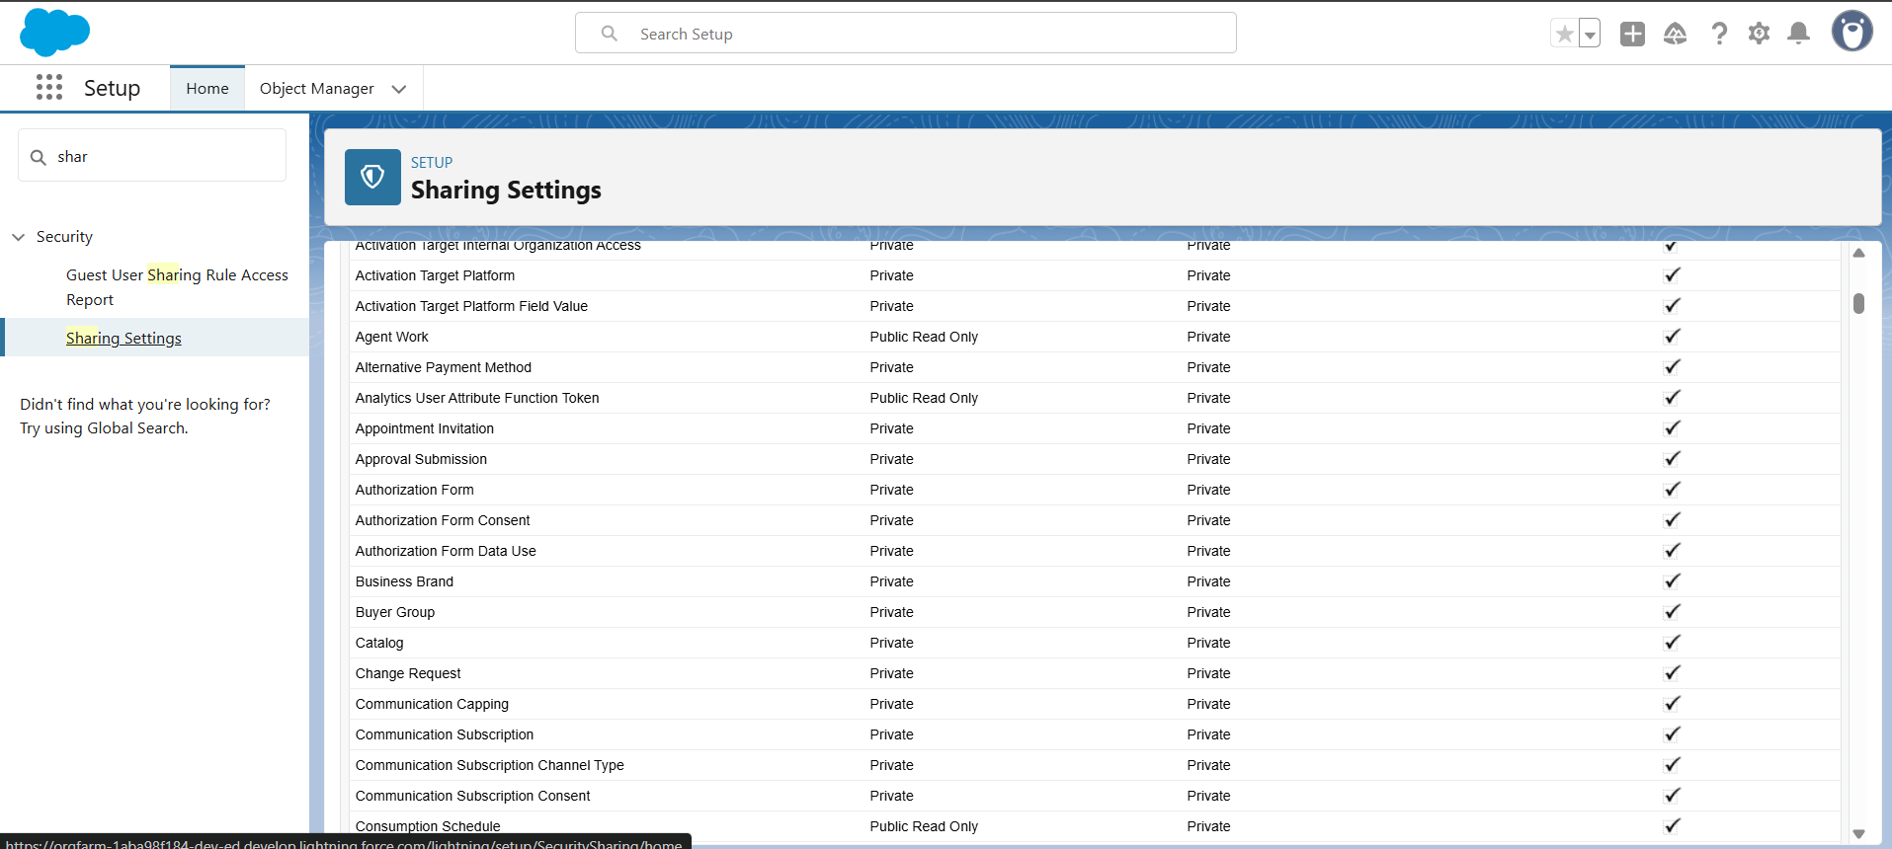

## Field Level Security

Use Case: This section explains how 'Field Level Security' is applied in the context of the Student Dropout Prediction system. Provide detailed explanation here.

## Session Settings

Use Case: This section explains how 'Session Settings' is applied in the context of the Student Dropout Prediction system. Provide detailed explanation here.  
  
Screenshot Placeholder: Insert relevant Salesforce screenshot here.

## Login IP Ranges

Use Case: This section explains how 'Login IP Ranges' is applied in the context of the Student Dropout Prediction system. Provide detailed explanation here.  
  
Screenshot Placeholder: Insert relevant Salesforce screenshot here.

## Audit Trail

Use Case: This section explains how 'Audit Trail' is applied in the context of the Student Dropout Prediction system. Provide detailed explanation here.  
  
Screenshot Placeholder: Insert relevant Salesforce screenshot here.

# Phase 10: Quality Assurance Testing

Phase 10: Quality Assurance Testing focuses on implementing key Salesforce concepts for the AI Dropout Prediction System. Below are the detailed components with explanations and placeholders for screenshots.

## Test Cases preparation for implemented features

Use Case: This section explains how 'Test Cases preparation for implemented features' is applied in the context of the Student Dropout Prediction system. Provide detailed explanation here.

## Input details, Expected Output, Actual Output

Use Case: This section explains how 'Input details, Expected Output, Actual Output' is applied in the context of the Student Dropout Prediction system. Provide detailed explanation here.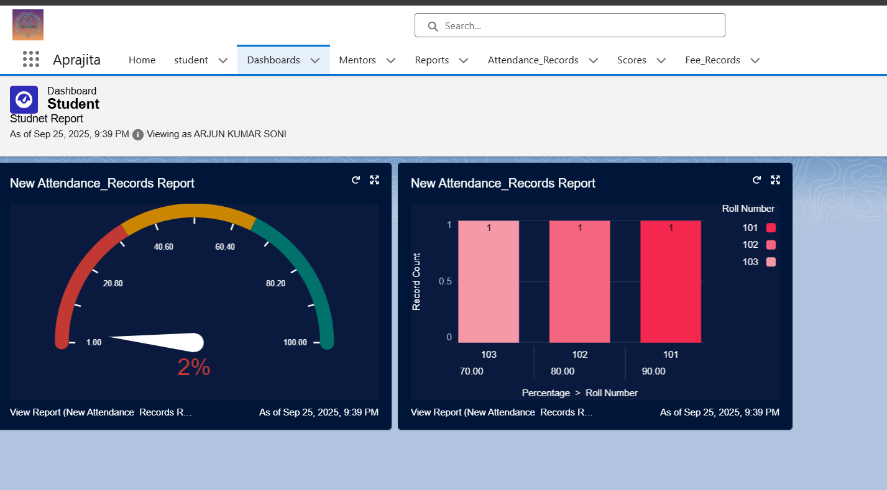

## Screenshots for verification

Use Case: This section explains how 'Screenshots for verification' is applied in the context of the Student Dropout Prediction system. Provide detailed explanation here.  
  
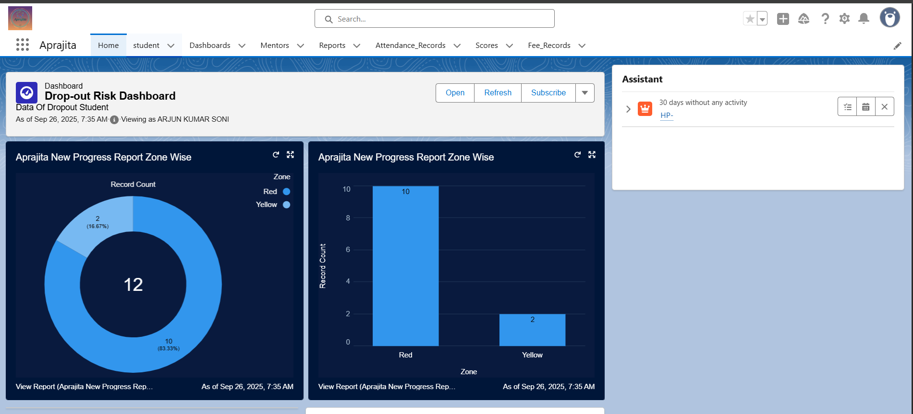

# Conclusion

The AI-Based Student Dropout Prediction & Counseling System successfully integrates Salesforce's CRM capabilities with AI-driven insights. Through this structured implementation, student data can be tracked, analyzed, and acted upon effectively. Future scope includes integration with advanced AI/ML models and external education platforms.